

AN ACADEMIC GRADING PLATFORM FOR BUNAWAN APLAYA ELEMENTARY SCHOOL

A Capstone Paper
Presented to the ITE Department
Philippine College of Technology
Gahol Drive, Davao City

In Fulfillment of the
Requirements for the course
Capstone 2

Members:
John Dave Bansag
Don Joshua Bongabong
Edmond Ambulario

June 2026

Abstract

The problem encountered by the Bunawan Aplaya Elementary school is that they lack an efficient system to keep track of their students’ records since most of their processes are still being done manually. Parents also have no idea nor access of what their children are accomplishing in school since they do not have immediate contact with their children’s teachers.
The Academic Grading Platform aims to serve as an easy-to-use tool for teachers and parents to communicate students’ academic accomplishments. Built with HTML, CSS, JavaScript, Node.js, Express.js as technologies. The methodologies used in this development are the Waterfall model since the required activities to build the system are already defined through interviews and actually observing the school and its processes. Administrators, Teachers, and Students/Parents have different dashboards and they can only access parts of the website that are intended for them. Teachers can post grades by simply uploading an Excel file with their student’s grades. This ensures that students will receive the correct grades from their teachers. Posted grades are subject for approval by the administrator. This grading platform consists of a login module, activate account module, student grades upload and management module, admin dashboard for easier view of student records, and a reports module. The system has been tested on different browsers as well as on different devices such as mobile phones to ensure that students can access it anywhere at anytime.
The Bunawan Aplaya Elementary School grading platform is hosted through Vercel and Railway which means that no software installation is required for this system to work. This system will benefit the school and students’ parents by giving parents access of what their children are achieving in school. It can also help parents take part in improving their children’s education as soon as they see signs of decline in grades.
Acknowledgment

This project is made possible through the help and support from everyone, including: parents, teachers, friends, and in essence all sentient beings. Especially, please allow us to dedicate our acknowledgment of gratitude toward the following significant adviser and contributors.

First and foremost, we would like to thank God for his unconditional guidance and wisdom as we make our project.

Second, we would like to thank our instructor MR. John Ray Josol and our coordinator Mrs. Marissa Antig for their most support and encouragement for giving us this project. This give us the experience on how to cooperate and engage ourselves in a serious project.

Finally, we sincerely thank to our parents, family, and friends who provide the advice and financial support. The product of this project would not be possible without all of them.

TABLE OF CONTENTS

Abstract …….. ................................................................................................. i
Acknowledgment Letter.................................................................................... ii

Chapter 1: Introduction................................................................................. 1
1.0 Project Context................................................................................ 1
1.1 Purpose and Description .......................................................... 1
1.3 Objectives ...................................................................................... 1
1.3.1 Specific objectives ................................................................. 2
1.4 Scope and limitation ....................................................................... 2
1.4.1 Scope ..................................................................................... 2
1.4.2 Limitation ................................................................................ 3

Chapter 2: Review of Related Literature / System ................................ 3
2.1 Local ............................................................................................... 3
2.2 National .......................................................................................... 3
2.3 International ................................................................................... 4

Chapter 3: Methodology…………............................................................ 4
3.1 Research Design............................................................................. 4
3.2 Development Tools…………………………………………………….. 5
3.3 System Architecture……………………………………………………. 6
3.4 Data Flow Diagram…………………………………………………….. 7
3.5 Entity Relationship Diagram…………………………………………… 7

Chapter 4: Results and Discussion….................................................... 9
4.1 System Features..............................................................................9
4.2 System Interface……..................................................................... 10
4.3 Testing and Evaluation……………………………………………….. 10

Chapter 5: Summary, Conclusion, and Recommendation…………….12 5.1 Summary...…………………………………………………………...…12
5.2 Conclusion……………………………………………………………...12
5.3 Recommendations……………………………………………………..12

References………..……………………..…………………………………….12
Appendicies……………………………………………………………………14

Chapter I: Introduction

A grade portal is an online platform most commonly used in college universities and private institutions that would allow students and their parents to view their academic performances mainly focusing on grades and other school related information.

The researchers plan to develop a system with the title “An Academic Grading Platform for Bunawan Aplaya Elementary School” and as the title suggests, it would focus on a public elementary school far from the heart of the city where not much of modern technology is being used.

1.1 Project Context

Elementary schools still face many challenges today such as effectively monitoring student performances as a result of continuous use of managing records using outdated systems. On the parents' side, is the lack of access to information regarding the student's academic advancement. The lack of timely exchanges of information on the performance of students from teachers to parents can have a negative impact on the academic performance of the student.
Integrating an accessible grading system will significantly help in monitoring the academic performance of the student for both teachers and parents. It will provide teachers the ability to input grades and document evaluations of the student's behavior toward specific subjects and activities. Different levels of access are implemented to control the actions that can be made, depending on the user being a teacher or parent, to ensure the integrity and privacy of data.

1.2 Purpose and Description

The grade portal is developed to improve the monitoring of the academic development of all students in Bunawan Aplaya Elementary School. It functions as a digital record for teachers to input the performance of the students while providing viewership for parents on the records to ensure early intervention depending on the performance of the student.
The system is a web-based application that operates as an interactive digital platform to disseminate the academic performance of the students in Bunawan Aplaya Elementary provided by teachers for the parents to have up-to-date information on the progress of the academic development of the students.

1.3 Objectives
The overall goal of this research is to develop a grade portal for Bunawan Aplaya Elementary School to increase the efficiency of academic performance provided by teachers so the parents have access to the academic records of the student. To elaborate, this research aims to:
Develop a grading system: to increase the efficiency of academic performance monitoring of teachers and parents regarding the students.

Acts as a digital record: for teachers to upload and manage the grades of students efficiently to improve work productivity.
Provide parents with real-time: information on the academic performance of the student.
Evaluates student performance: in the event of an increase or decrease in performance levels of the student.

1.4 Scope and Limitation
The scope of the study includes the development of a system that will assist teachers in recording and monitoring the grades of students, which will then be provided for parents to have access to view the academic progress of the student.
Scope

Teachers can upload the grades of students on the system for parents to view on the respective account of each student.

The functionality of the student dashboard is only focused on viewing grades as provided by the teacher.

Limitation

The website can only be accessed if the user is connected to the internet

The proposed system is limited to individuals with existing records in the school database; therefore, only authorized and registered users can use the system.

The system will only act as support for parents and teachers to monitor the academic performance of the student to uphold the traditional practices between parents and teachers.

Chapter II: Review of Related Literature
2.1 Local
Mobile-Web Responsive Portal for St. John Paul II College of Davao Applying Predictive Analytics Techniques

Studies have shown that the use of a Mobile-Web responsive portal in St. John Paul II College of Davao have named Classification and Regression Tree (CART), the system addressed the drawbacks of traditional, manual systems that lead to increased productivity and user satisfaction given by the students and staff.
It is evident that with the use of effective online systems the users are satisfied with the fast paced services provided by the system, with this in mind the grade portal that the researchers are developing for Bunawan Aplaya Elementary School will help parents have quick access to the academic records of their children via mobile-web based portal.
National
Enhancing Parental Engagement via the Grade Viewer Application: A Study in Taganaan National High School
As research suggests, parent involvement is crucial for the academic growth of a student, with the help of a grade viewing web application, it bridges the gap between the parents and school and its educators (Perfecto R. Ruaya, Jr., 2023). Children need guidance in the early stages of their lives to prevent them from taking the wrong path. More often than not, children tend to make fewer mistakes when they know they are being watched.
With the use of an online website application such as the Grade Portal for Bunawan Aplaya Elementary School that enables parents to view the grades of the student, they can efficiently monitor the academic performance of the student whenever and wherever, as long as it is provided to them by the teacher via the online website.
International
Using School Websites for Home-School Communication and Parental Involvement
The research has found that schools often limit themselves to communicating only the social aspects of student development rather than issues that are related to teaching, which suggests that schools are indirectly encouraging parents to focus on the overall well-being of the students, leaving the pedagogical matters to the teachers.
We, the researchers, have added features to the online website to encourage the school to address their concerns regarding parental volunteerism in school activities to enhances home-school relationships for more productive results in the enhancement of the academic performance of the students.
CHAPTER III: TECHNICAL BACKGROUND AND METHODOLOGY
3.1 Research Design

This study uses a developmental research design using the Waterfall methodology as the systematic framework for developing the Academic Grading Platform for Bunawan Aplaya Elementary School. The use of developmental research is appropriate for this study because the main objective is to design and build a functional information system that addresses a problem has always been present in underdeveloped schools with regards to managing and

The Waterfall methodology was selected as the development framework because the requirements for the grading platform have already been laid out. The core functionalities of the system were developed to cater issues that were identified at the outset through interviews and observations conducted at the school. Since the circumstances are unlikely to shift significantly during the development period, the sequential structure of Waterfall provides a structured process from planning to deployment.

3.2 Development Tools

The researchers used different software and technologies in developing the Academic Grading Platform for Bunawan Aplaya Elementary School. These tools helped in designing, coding, testing, and deploying the system efficiently.

Frontend Technologies:
These are the tools used to create what the users see and interact with, they provide its appeal and interactions for a user-friendly experience.

The frontend of the system was developed using:

HTML – acts as the backbone of our system in which it sets the structure of the for each header, button, or image.
CSS – gives appeal to the system providing aspects that is not hard for the user’s eyes.
JavaScript – used for interactive functions and dynamic features of the website.

Backend Technologies:
To ensure system internal functionality, these tools were used to apply logic to the system, handle user requests, and manage data processing.

The backend of the system was developed using:
Node.js – used as the server-side environment to process request and handle system operations.
Express.js – used to build APIs, routes, authentication, and backend functions.
Database Management:
Tools used to store data of user to ensure accurate information are provided to users.
The data of the system was stored using:
MySQL — used as the main database for storing student records, grades, school years, sections, and subjects.
MySQL Workbench — used to design, manage, and execute database queries.
Development Tools:
The researchers utilized the following tools:

Visual Studio Code – is the development environment used to build the system, here is where the source code was written, where backend logic was implemented, and develop internal functionalities.
Thunder Client — used for API testing and checking backend requests.

File and Data Processing Libraries:
Specific tools used to integrate external data files provided by user to upload to the system.

External user uploads were accepted using:
Multer — used for file upload handling.
SheetJS — used for reading and processing Excel files for grade uploads.

3.3 System Architecture
The system follows a client-server architecture.

Presentation Layer: it is the interface users can see and interact with, which was built using HTML, CSS, and JavaScript.

Application Layer: To implement logic to the system Node.js and Express.js have been used. It handles user requests, build user authentication, APIs routes, and backend functions.

Data Layer: MYSQL was used to store user data for its high performance in handling data with integrity and compatibility with other existing tools that have been used to develop the system.

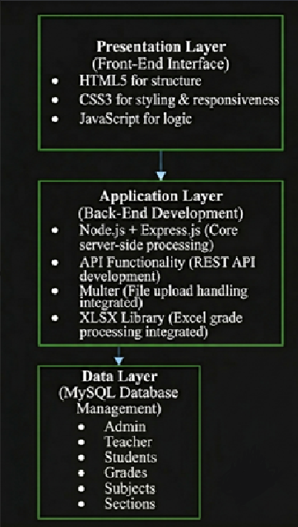
Figure 3.3.1: System Architecture Diagram

3.4 Data Flow Diagram (DFD)
The Data Flow Diagram illustrates how information moves within the system, it shows how data is collected and distributed to ensure functionality and user authentication is implemented for user security.

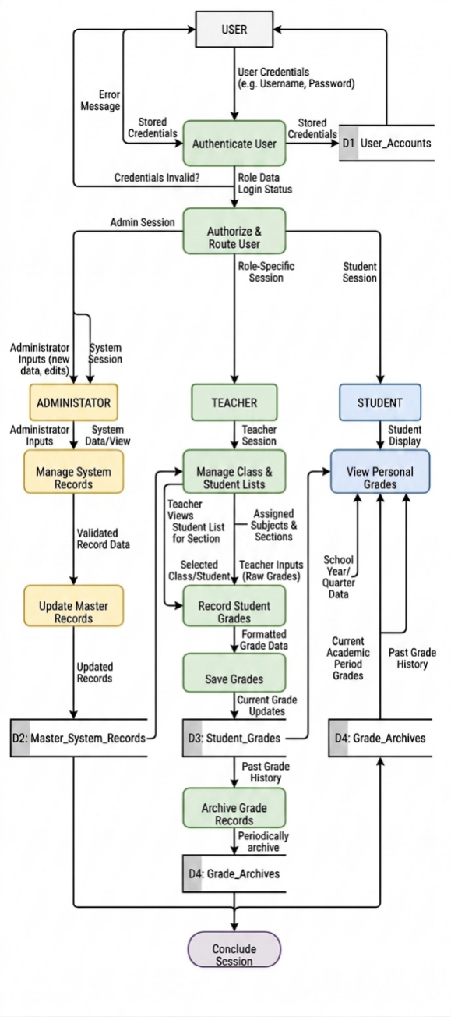
Figure 3.4.1: Data Flow Diagram

3.5 Entity Relationship Diagram
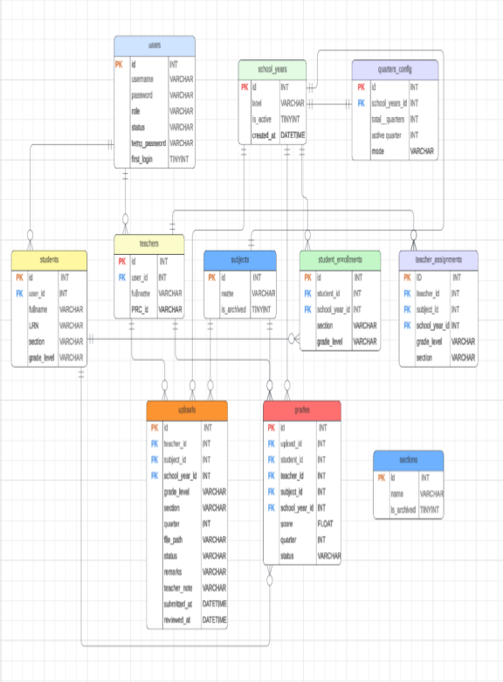
The Grading Portal System database is composed of eleven interrelated tables that collectively manage user authentication, academic records, and grade submission workflows. The database is designed to support three types of users: administrators, teachers, and students, each with distinct roles and access levels within the system. The following sections describe each entity (table) in the database, including its attributes, data types, and relationships with other entities.

Figure 3.5.1: Entity Relationship Diagram

The entities are as follows:

Users
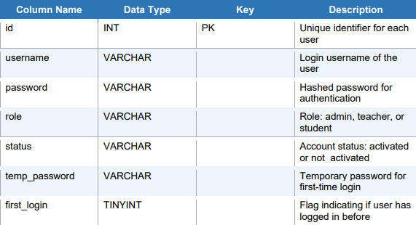
Table 3.5.1: User Table

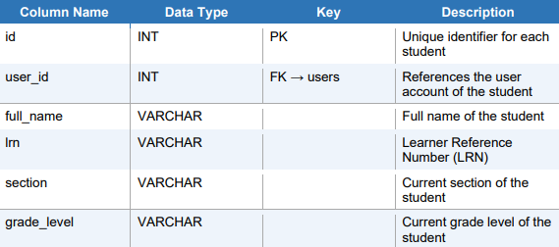
Students
3.5.2: Students Table

Teachers
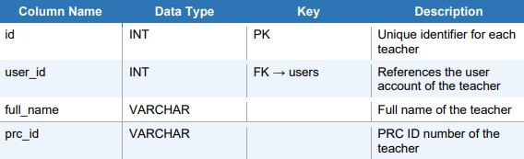
3.5.3: Teachers table

School years
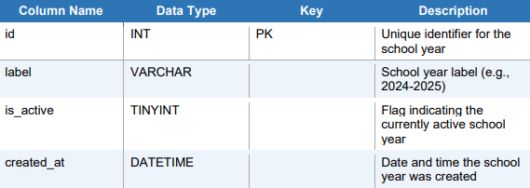
3.5.3: School Years Table

Quarters Configuration
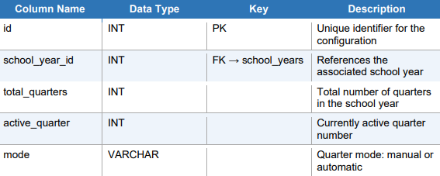
3.5.3: Quarters Configuration Table

Subjects
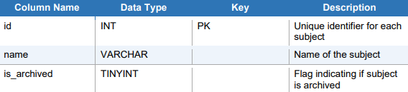
3.5.3: Subjects Table

Sections
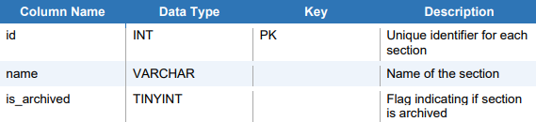
3.5.3: Sections Table
Uploads
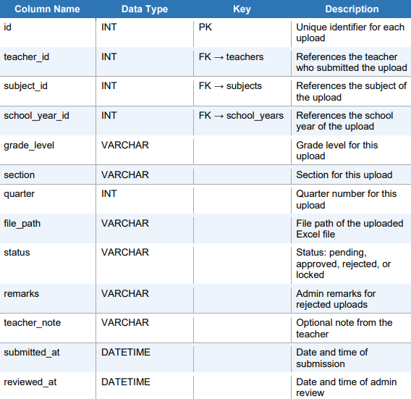
3.5.3: Uploads Table

CHAPTER IV: Results and Discussion
4.1 System Features
The Grade Portal introduces features that meet user needs and satisfaction while ensuring digital inclusivity to all users through accessible means and promoting a user-friendly environment.

Login Module: The user login provides access to admin, student, and teachers and uses unique indentifiers that primarily exist on school records to ensure the security and integrity o our system to prevent outside entities in taking hold of confidential information.
Student Profile Module: Registered students have access to their user profile after being successfully registered and activating the account through user authentication backed up system data, that lets them view their grade for each grading period through web browsers.

Teacher Profile Module: Teachers are able to upload grades using excel files from excel files from their existing records for students to view, they will also have lists of classes they supervise shown on record.

Admin Dashboard Module: User registration can only be made through the admin dashboard to ensure only school registered users get accounts made on their behalf to ensure user security and information safety will not be compromised.

Reports Generation: This feature tracks all existing accounts on the system, enable Admin users to tally the number of records from various categories for simpler data handling.

4.2 System Interface
The system interface was made from a user’s perspective and satisfaction to prevent any confusions or user errors. By using straightforward symbols and descriptions, users can navigate the system seamlessly.

Admin Dashboard
Shown in Figure 4.2.1 is the Admin Dashboard Homepage, presenting the tally of all accounts being handled, a tracker or actions that have been made, and pending tasks with a simple yet comprehensive design.

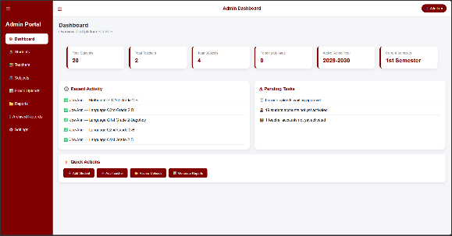
Figure 4.2.1: Admin Dashboard Interface

Teacher Dashboard
In Figure 4.2.2 shows the Teacher Dashboard that presents their assigned subjects and classes, including shortcuts of actions they can do to improve productivity.
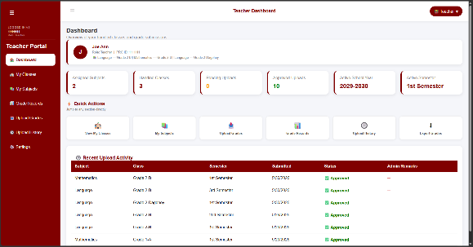
Figure 4.2.2: Teacher Dashboard Interface

Student Dashboard
Figure 4.2.3 shows the Student Dashboard presenting the current grade level of the student, which class, and the recent grades that have been recently uploaded.

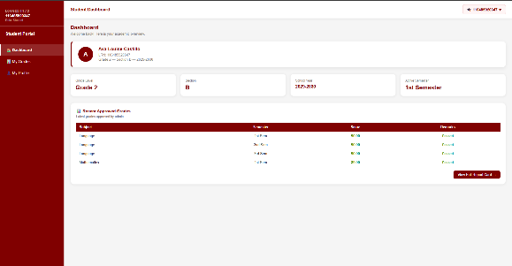
Figure 4.2.3: Student Dashboard Interface

4.3 Testing and Evaluation
The Grading Portal System is a web-based application developed to digitize and streamline the grade management process. The system was developed and tested on multiple hardware devices and is accessible through modern web browsers on both desktop and mobile platforms. This section outlines the hardware and software specifications used during development, as well as the minimum requirements for end users to access the system.

4.3.1 Compatibility Testing
The system was tested across multiple devices, browsers, and operating systems to ensure broad accessibility and compatibility. The following table summarizes the devices and browsers used during compatibility testing:
Desktop and Laptop Browsers: shown in table 4.3.1 are compatible browsers for Grade Portal System.
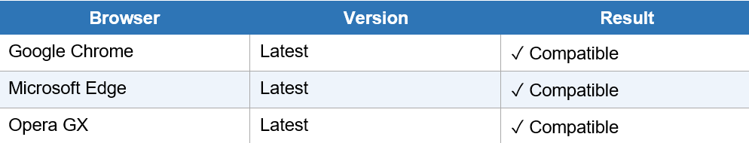
Table 4.3.1: Desktop and Browser Compatability Testing
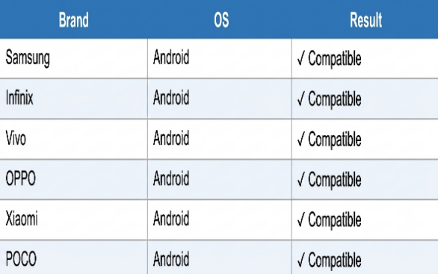
Mobile Devices: shown in table are compatible mobile devices for the Grade Portal System.
Table 4.3.2: Mobile Devices Compatability Testing

4.3.2 Minimum System Requirements for End Users
Since the Grading Portal System is a web-based application hosted on cloud servers (Vercel for frontend and Railway for backend), end users are not required to install any software. The following are the minimum requirements to access and use the system:
Desktop and Laptop: shown in table 4.3.3 are the minimum requirements for desktops and laptops users can use to access the Grade Portal System.
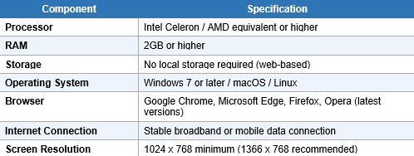
Table 4.3.3: Minimum System Requirement for End Users for Desktop and Laptop
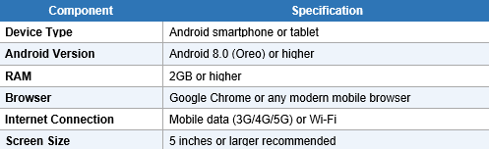
Mobile Devices: shown in table 4.3.4 are the minimum requirements for mobile devices users can use to access the Grade Portal System.
Table 4.3.4: Minimum System Requirement for End Users for Mobile Devices
Chapter V: Summary, Conclusion, and Recommendations
5.1 Summary
The Academic Grading Portal for Bunawan Aplaya Elementary school is an online platform that is designed to allow students and parents to have real-time access to student performance, at the same time providing an effective data management tool for school administration and faculty.
5.2 Conclusion
The Academic Grading Portal for Bunawan Aplaya Elementary School will help the parents monitor their child’s performance to ensure they perform well in school to establish a solid foundation of their education at a young age.
5.3 Recommendations
Bunawan Aplaya Grading Portal Application Development
To enhance user accessibility and productivity, a mobile application counterpart of the website should be developed to provide easier access.
An Embedded Mini-game for student Learning and Interactivity
To encourage students in engaging with the website, an interactive game mini-game will be integrated in the future. This feature would monitor the progress of the students and be given added points by teachers after reaching a milestone achievement.
SMS Offline Notification Feature
To improve productivity of the users, an offline notification feature via SMS should be added to alert users of tasks, uploads, and announcements for inclusivity particularly to user who has limited internet connectivity.

References
Adorico, K. S. O., & Yara, F. (2024). Mobile-Web Responsive Portal for St. John Paul II College of Davao Applying Predictive Analytics Techniques. https://www.researchgate.net/publication/381229033_Mobile-Web_Responsive_Portal_for_St_John_Paul_II_College_of_Davao_Applying_Predictive_Analytics_Techniques
Ruaya, P. R., Jr. (2023). Enhancing parental engagement via the Grade Viewer Application: A study in Taganaan National High School. International Journal of Advanced Research in Science, Communication and Technology, 3(2), 177–183. https://www.researchgate.net/publication/372756475_Enhancing_Parental_Engagement_via_the_Grade_Viewer_Application_A_Study_in_Taganaan_National_High_School
Gu, L. (2017). Using school websites for home–school communication and parental involvement? Nordic Journal of Studies in Educational Policy, 3(2), 133–143. https://www.tandfonline.com/doi/full/10.1080/20020317.2017.1338498

APPENDICIES
- Request Letter
- Acceptance Letter
- Certificate of Deployment
- Grammarian Certificate
- Organizational Structure
  - Curriculum Vitae of Members
- Ai Detector Result
- Source Code

REQUEST LETTER
April 01, 2026

Chona F. Nieves, MAEM
DepEd Teacher III
Bunawan Aplaya Elementary School
Km. 24 Bunawan, Davao City

Dear Ma’am Nieves,

We, John Davao Bansag, Don Joshua Bongabong, Edmond Ambulario, Diploma in Information Technology students, respectfully request permission to conduct our Capstone study entitled “An Academic Grading Platform for Bunawan Aplaya Elementary School.”

In this regard, we seek approval to conduct our research at Bunawan Aplaya Elementary School, including interviews, data gathering, and system-related activities.

The study aims to develop a platform for teachers to upload the grades of their students for them to view online.

Rest assured that all information gathered will be kept confidential and used strictly for academic purposes.

We are looking forward for your favourable response to our request. Thank you in anticipation .

Respectfully yours,

The Researchers,

John Dave Bansag

Don Joshua Bongabong

Edmond Ambulario

Jeffrey D. Oñas, MIM John Ray Josol
Program Head Capstone Instructor

Marissa Antig Chona F. Nieves, MAEM
Program Coordinator DepEd Teacher III

ACCEPTANCE LETTER
May 10, 2026

Chona F. Nieves, MAEM
DepEd Teacher III
Bunawan Aplaya Elementary School
Km. 24 Bunawan, Davao City
Dear Ma’am Nieves,
This letter serves as formal approval for the capstone project entitled “An academic Grading Platform for Bunawan Aplaya Elementary School.”
After reviewing the project proposal, Bunawan Aplaya Elementary School, grants permission for the conduct, implementation, and pilot testing of the system within the institution. The project is recognized as a valuable initiative to enhance the documentation and monitoring of students’ learning progress.
Approval is granted provided that all activities are coordinated with the administration, institutional policies are observed, collected data remain confidential and used solely for academic purposes, and regular school operations are not disrupted. A copy of the final system and documentation shall be submitted upon project completion.
We look forward to supporting the successful completion of this project.
Sincerely yours,
The Researchers,
John Dave Bansag
Don Joshua Bongabong
Edmond Ambulario

Jeffrey D. Oñas, MIM John Ray Josol
Program Head Capstone Instructor

Marissa Antig Chona F. Nieves, MAEM
Program Coordinator DepEd Teacher III

CERTIFICATION
May 18, 2026

Chona F. Nieves, MAEM
DepEd Teacher III
Bunawan Aplaya Elementary School
Km. 24 Bunawan, Davao City
Dear Ma’am Nieves,
We, the undersigned Diploma in Information Technology students, hereby certify that our capstone project entitled "An academic Grading Platform for Bunawan Aplaya Elementary School" has been officially approved, implemented, and deployed at Bunawan Aplaya Elementary School.
The system was developed as part of our academic requirements and has undergone planning, development, testing, and evaluation within the institution. It presents as a web-based school portal accessible via web browser on both desktop and mobile devices, that lets teachers upload the grades of their students online for both students and parents to review made specifically for administrators, teachers, and parents of Bunawan Aplaya Elementary School.
We were granted permission to conduct all necessary activities, including requirements gathering, system development, user testing, and deployment, in accordance with institutional policies.
This certification is issued upon the request of the above-named students for whatever legal and academic purposes it may serve.
Sincerely yours,
The Researchers,
John Dave Bansag
Don Joshua Bongabong
Edmond Ambulario
Jeffrey D. Oñas, MIM John Ray Josol
Program Head Capstone Instructor

Marissa Antig Chona F. Nieves, MAEM
Program Coordinator DepEd Teacher III
GRAMMARIAN CERIFICATE


ORGANIZATIONAL STRUCTURE
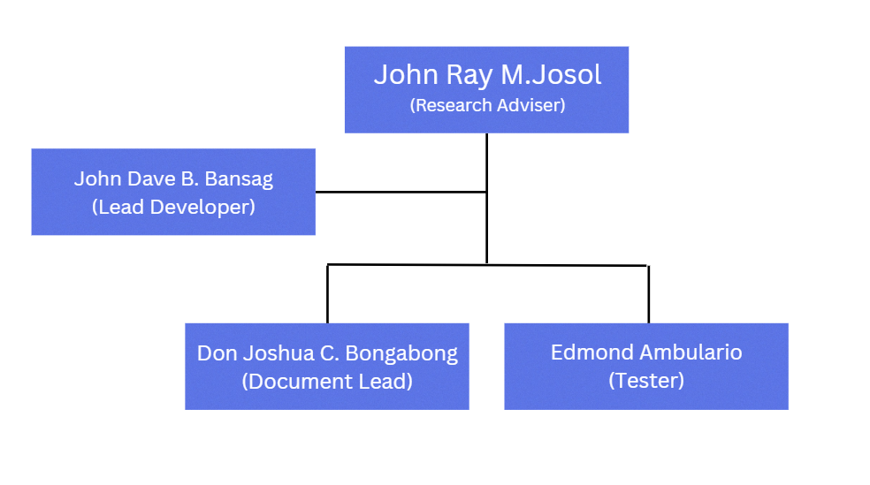

Curriculum Vitae of Members
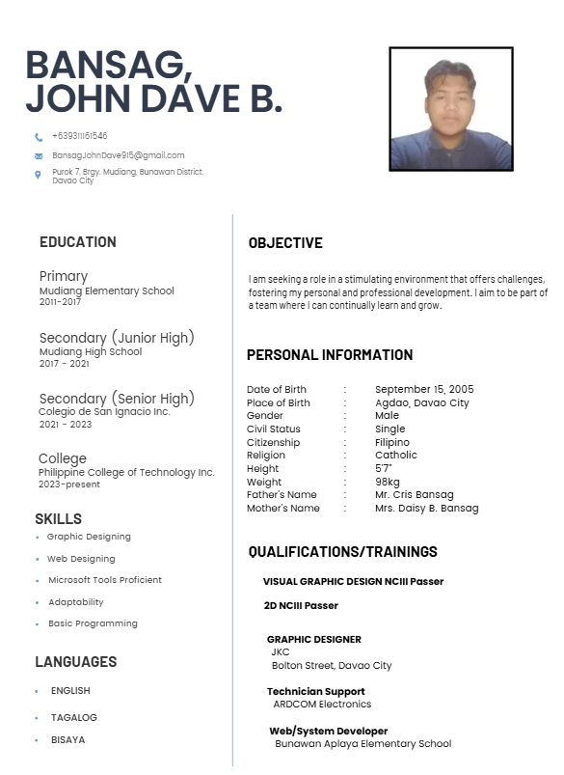




AI DETECTOR RESULT
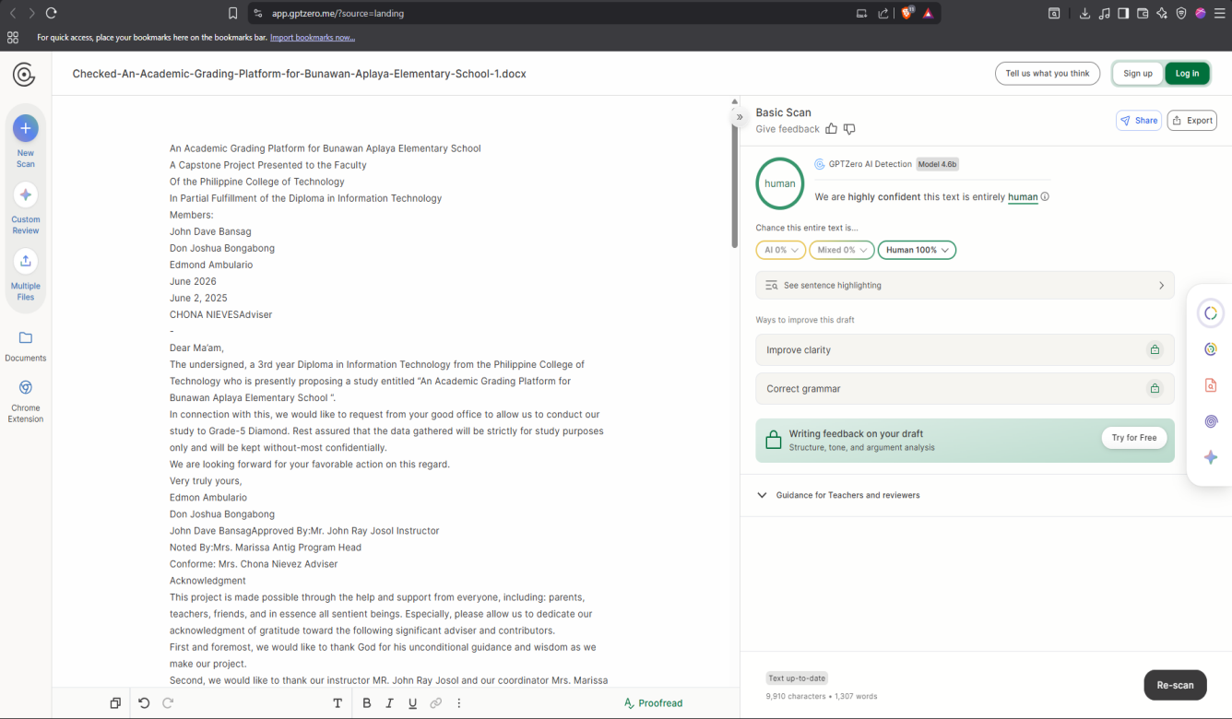

SOURCE CODE

Database Configuration
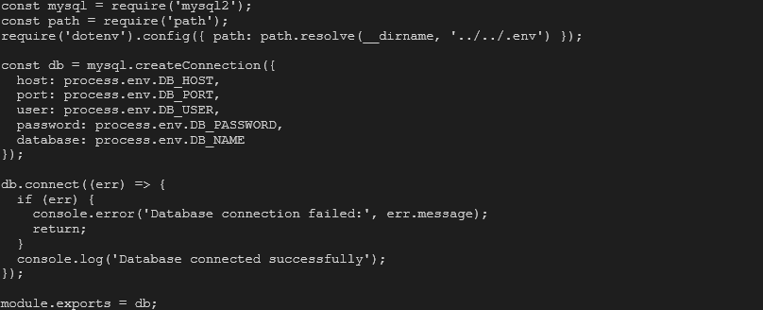

Authentication Middlewar

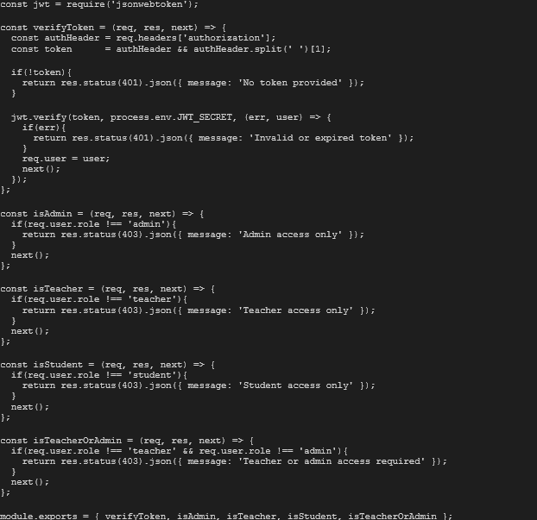

Main Server Entry Point
const express = require('express');
const cors = require('cors');
const path = require('path');
require('dotenv').config();

const db = require('./config/db');

const authRoutes = require('./routes/authRoutes');
const studentRoutes = require('./routes/studentRoutes');
const teacherRoutes = require('./routes/teacherRoutes');
const subjectRoutes = require('./routes/subjectRoutes');
const schoolYearRoutes = require('./routes/schoolYearRoutes');
const gradeRoutes = require('./routes/gradeRoutes');
const sectionRoutes = require('./routes/sectionRoutes');
const reportRoutes = require('./routes/reportRoutes');
const app = express();

app.use((req, res, next) => {
const origin = req.headers.origin;
if (origin && (origin.includes('netlify.app') || origin.includes('vercel.app'))) {
res.header("Access-Control-Allow-Origin", origin);
}
res.header("Access-Control-Allow-Methods", "GET, POST, PUT, DELETE, OPTIONS");
res.header("Access-Control-Allow-Headers", "Origin, X-Requested-With, Content-Type, Accept, Authorization");
res.header("Access-Control-Allow-Credentials", "true");
if (req.method === "OPTIONS") {
return res.status(200).end();
}
next();
});
app.use(express.json());
app.use(express.static(path.join(__dirname, '../')));
app.use('/assets', express.static(path.join(__dirname, '../assets')));
app.get('/health', (req, res) => res.status(200).send('OK'));
app.use('/api/auth', authRoutes);
app.use('/api/students', studentRoutes);
app.use('/api/teachers', teacherRoutes);
app.use('/api/subjects', subjectRoutes);
app.use('/api/school-years', schoolYearRoutes);
app.use('/api/grades', gradeRoutes);
app.use('/api/sections', sectionRoutes);
app.use('/api/reports', reportRoutes);

app.get('/', (req, res) => {
res.sendFile(path.join(__dirname, '../index.html'));
});

process.on('uncaughtException', (err) => {
console.error('Uncaught Exception:', err.message);
console.error(err.stack);
});

const PORT = process.env.PORT || 8080;
app.listen(PORT, '0.0.0.0', () => {
console.log(`Server running on port ${PORT}`);
});

Authentication Controller
const db = require('../config/db');
const bcrypt = require('bcryptjs');
const jwt = require('jsonwebtoken');
require('dotenv').config();

// ==========================
// LOGIN
// ==========================

const login = (req, res) => {

const { username, password } = req.body;

if(!username || !password){
return res.status(400).json({
message: 'Username and password are required'
});
}

const sql = 'SELECT * FROM users WHERE username = ?';

db.query(sql, [username], async (err, results) => {

if(err) return res.status(500).json({ message: 'Server error' });

if(results.length === 0){
return res.status(401).json({
message: 'Invalid username or password'
});
}

const user = results[0];

// block if not activated
if(user.status === 'not_activated'){
return res.status(403).json({
message: 'Account not yet activated. Please activate your account first.',
code: 'NOT_ACTIVATED'
});
}

// check password
const isMatch = await bcrypt.compare(password, user.password);

if(!isMatch){
return res.status(401).json({
message: 'Invalid username or password'
});
}

// generate JWT
const token = jwt.sign(
{ id: user.id, role: user.role },
process.env.JWT_SECRET,
{ expiresIn: '24h' }
);

res.json({
message: 'Login successful',
token,
role: user.role,
username: user.username
});

});

};

// ==========================
// ACTIVATE — STUDENT
// ==========================

const activateStudent = async (req, res) => {

const {
lrn,
full_name,
temp_password,
new_password,
confirm_password
} = req.body;

if(!lrn || !full_name || !temp_password || !new_password || !confirm_password){
return res.status(400).json({ message: 'All fields are required' });
}

if(new_password !== confirm_password){
return res.status(400).json({ message: 'Passwords do not match' });
}

if(new_password.length < 8){
return res.status(400).json({
message: 'Password must be at least 8 characters'
});
}

// find student by LRN
const sql = `
SELECT s.*, u.status, u.id AS user_id, u.temp_password AS stored_temp
FROM students s
JOIN users u ON s.user_id = u.id
WHERE s.lrn = ?
`;

db.query(sql, [lrn], async (err, results) => {

if(err) return res.status(500).json({ message: 'Server error' });

if(results.length === 0){
return res.status(404).json({
message: 'LRN not found. Please contact your administrator.'
});
}

const student = results[0];

// already activated?
if(student.status === 'activated'){
return res.status(400).json({
message: 'Account already activated. Please login normally.',
code: 'ALREADY_ACTIVATED'
});
}

// verify full name
const dbName = student.full_name.toLowerCase().trim();
const inputName = full_name.toLowerCase().trim();

if(dbName !== inputName){
return res.status(401).json({
message: 'Full name does not match our records.'
});
}

// verify temp password against stored plain temp
if(temp_password !== student.stored_temp){
return res.status(401).json({
message: 'Incorrect temporary password.'
});
}

// all verified — activate
completeActivation(student.user_id, new_password, res);

});

};

// ==========================
// ACTIVATE — TEACHER
// ==========================

const activateTeacher = async (req, res) => {

const {
prc_id,
full_name,
temp_password,
new_password,
confirm_password
} = req.body;

if(!prc_id || !full_name || !temp_password || !new_password || !confirm_password){
return res.status(400).json({ message: 'All fields are required' });
}

if(new_password !== confirm_password){
return res.status(400).json({ message: 'Passwords do not match' });
}

if(new_password.length < 8){
return res.status(400).json({
message: 'Password must be at least 8 characters'
});
}

// find teacher by PRC ID
const sql = `
SELECT t.*, u.status, u.id AS user_id, u.temp_password AS stored_temp
FROM teachers t
JOIN users u ON t.user_id = u.id
WHERE t.prc_id = ?
`;

db.query(sql, [prc_id], async (err, results) => {

if(err) return res.status(500).json({ message: 'Server error' });

if(results.length === 0){
return res.status(404).json({
message: 'PRC ID not found. Please contact your administrator.'
});
}

const teacher = results[0];

// already activated?
if(teacher.status === 'activated'){
return res.status(400).json({
message: 'Account already activated. Please login normally.',
code: 'ALREADY_ACTIVATED'
});
}

// verify full name
const dbName = teacher.full_name.toLowerCase().trim();
const inputName = full_name.toLowerCase().trim();

if(dbName !== inputName){
return res.status(401).json({
message: 'Full name does not match our records.'
});
}

// verify temp password
if(temp_password !== teacher.stored_temp){
return res.status(401).json({
message: 'Incorrect temporary password.'
});
}

// all verified — activate
completeActivation(teacher.user_id, new_password, res);

});
};
// ==========================
// COMPLETE ACTIVATION
// ==========================

async function completeActivation(userId, newPassword, res){

try {

const hashedPassword = await bcrypt.hash(newPassword, 10);

const sql = `
UPDATE users
SET password = ?,
status = 'activated',
temp_password = NULL,
first_login = 0
WHERE id = ?
`;

db.query(sql, [hashedPassword, userId], (err) => {
if(err) return res.status(500).json({ message: 'Server error' });

res.json({
message: 'Account activated successfully! You can now login.'
});
});

} catch(err) {
res.status(500).json({ message: 'Server error' });
}

}
const changeAdminCredentials = async (req, res) => {

const { current_password, new_username, new_password } = req.body;
const userId = req.user.id;

if(!current_password){
return res.status(400).json({
message: 'Current password is required'
});
}

if(!new_username && !new_password){
return res.status(400).json({
message: 'Provide a new username or new password'
});
}

try {

// get current user
const [users] = await db.promise().query(
'SELECT * FROM users WHERE id = ?',
[userId]
);

if(users.length === 0){
return res.status(404).json({ message: 'User not found' });
}

const user = users[0];

// verify current password
const isMatch = await bcrypt.compare(current_password, user.password);
if(!isMatch){
return res.status(400).json({
message: 'Current password is incorrect'
});
}

// build update
const updates = [];
const params = [];

if(new_username && new_username.trim() !== user.username){
// check username not taken
const [existing] = await db.promise().query(
'SELECT id FROM users WHERE username = ? AND id != ?',
[new_username.trim(), userId]
);
if(existing.length > 0){
return res.status(400).json({
message: 'Username already taken'
});
}
updates.push('username = ?');
params.push(new_username.trim());
}

if(new_password){
if(new_password.length < 6){
return res.status(400).json({
message: 'New password must be at least 6 characters'
});
}
const hashed = await bcrypt.hash(new_password, 10);
updates.push('password = ?');
params.push(hashed);
}

if(updates.length === 0){
return res.status(400).json({
message: 'No changes detected'
});
}

params.push(userId);

await db.promise().query(
`UPDATE users SET ${updates.join(', ')} WHERE id = ?`,
params
);

res.json({
message: 'Credentials updated successfully. Please log in again.',
username_changed: !!new_username
});

} catch(err) {
console.error('Change credentials error:', err);
res.status(500).json({ message: 'Server error' });
}
};

const changePassword = async (req, res) => {

const { current_password, new_password } = req.body;
const userId = req.user.id;

if(!current_password || !new_password){
return res.status(400).json({
message: 'Current password and new password are required'
});
}

if(new_password.length < 6){
return res.status(400).json({
message: 'New password must be at least 6 characters'
});
}

try {

const [users] = await db.promise().query(
'SELECT * FROM users WHERE id = ?',
[userId]
);

if(users.length === 0){
return res.status(404).json({ message: 'User not found' });
}

const isMatch = await bcrypt.compare(current_password, users[0].password);
if(!isMatch){
return res.status(400).json({ message: 'Current password is incorrect' });
}

const hashed = await bcrypt.hash(new_password, 10);

await db.promise().query(
'UPDATE users SET password = ? WHERE id = ?',
[hashed, userId]
);
res.json({
message: 'Password changed successfully. Please log in again.'
});

} catch(err) {
console.error('Change password error:', err);
res.status(500).json({ message: 'Server error' });
}
};
module.exports = {
login,
activateStudent,
activateTeacher,
changeAdminCredentials,
changePassword
};

Student Controller (All functions)
const db = require('../config/db');
const bcrypt = require('bcryptjs');

function generateTempPassword(fullName, idNumber) {
const nameParts = fullName.trim().split(' ');
const firstName = nameParts[0];
const lastName = nameParts[nameParts.length - 1];
const firstInitial = firstName[0].toUpperCase();
const last4 = String(idNumber).slice(-4);
return `${firstInitial}.${lastName}${last4}`;
}

const getAllStudents = (req, res) => {

const sql = `
SELECT
s.id,
s.lrn,
s.full_name,
s.is_archived,
COALESCE(u.status, 'not_activated') AS status,
se.grade_level,
se.section,
se.adviser,
sy.label AS school_year,
sy.id AS school_year_id
FROM students s
LEFT JOIN users u ON s.user_id = u.id
LEFT JOIN student_enrollments se ON s.id = se.student_id
LEFT JOIN school_years sy
ON se.school_year_id = sy.id
AND sy.is_active = 1
WHERE s.is_archived = 0
AND se.school_year_id = (
SELECT id FROM school_years WHERE is_active = 1 LIMIT 1
)
ORDER BY se.grade_level, se.section, s.full_name ASC
`;

db.query(sql, (err, results) => {
if(err) return res.status(500).json({
message: 'Server error',
error: err.message
});
res.json(results);
});

};

// GET all ARCHIVED students
const getArchivedStudents = (req, res) => {

const sql = `
SELECT
s.id,
s.lrn,
s.full_name,
s.archived_at,
s.archive_reason,
COALESCE(u.status, 'not_activated') AS status,
se.grade_level,
se.section,
sy.label AS school_year
FROM students s
LEFT JOIN users u ON s.user_id = u.id
LEFT JOIN student_enrollments se
ON se.student_id = s.id
AND se.id = (
SELECT id FROM student_enrollments
WHERE student_id = s.id
ORDER BY id DESC
LIMIT 1
)
LEFT JOIN school_years sy ON se.school_year_id = sy.id
WHERE s.is_archived = 1
ORDER BY s.archived_at DESC
`;

db.query(sql, (err, results) => {
if(err) return res.status(500).json({ message: 'Server error' });
res.json(results);
});

};

// GET single student
const getStudent = (req, res) => {
const { id } = req.params;
db.query(
'SELECT * FROM students WHERE id = ?',
[id],
(err, results) => {
if(err) return res.status(500).json({ message: 'Server error' });
if(results.length === 0) return res.status(404).json({ message: 'Student not found' });
res.json(results[0]);
}
);
};

// GET my profile (for logged-in student)
const getMyProfile = (req, res) => {
const userId = req.user.id;
const sql = `
SELECT
s.lrn, s.full_name,
u.status,
se.grade_level, se.section, se.adviser,
sy.label AS school_year,
sy.id AS school_year_id
FROM students s
JOIN users u ON s.user_id = u.id
JOIN student_enrollments se ON s.id = se.student_id
JOIN school_years sy ON se.school_year_id = sy.id
WHERE s.user_id = ?
ORDER BY sy.is_active DESC, sy.id DESC
LIMIT 1
`;
db.query(sql, [userId], (err, results) => {
if(err) return res.status(500).json({ message: 'Server error' });
if(results.length === 0){
return res.status(404).json({
message: 'Profile not found. Contact your administrator.'
});
}
res.json(results[0]);
});
};

// ADD student
const addStudent = async (req, res) => {
const { lrn, full_name, grade_level, section, adviser } = req.body;
if(!lrn || !full_name || !grade_level || !section){
return res.status(400).json({ message: 'LRN, full name, grade level, and section are required' });
}
try {
const tempPassword = generateTempPassword(full_name, lrn);
const hashedTemp = await bcrypt.hash(tempPassword, 10);
const userSql = `
INSERT INTO users (username, password, role, status, temp_password, first_login)
VALUES (?, ?, 'student', 'not_activated', ?, 1)
`;
db.query(userSql, [lrn, hashedTemp, tempPassword], (err, userResult) => {
if(err){
if(err.code === 'ER_DUP_ENTRY') return res.status(400).json({ message: 'LRN already exists' });
return res.status(500).json({ message: 'Server error', error: err.message });
}
const userId = userResult.insertId;
db.query(
'INSERT INTO students (lrn, full_name, user_id) VALUES (?, ?, ?)',
[lrn, full_name, userId],
(err2, studentResult) => {
if(err2) return res.status(500).json({ message: 'Server error' });
const studentId = studentResult.insertId;
db.query('SELECT id FROM school_years WHERE is_active = 1 LIMIT 1', (err3, years) => {
if(err3 || years.length === 0){
return res.status(500).json({ message: 'No active school year found' });
}
db.query(
'INSERT INTO student_enrollments (student_id, school_year_id, grade_level, section, adviser) VALUES (?, ?, ?, ?, ?)',
[studentId, years[0].id, grade_level, section, adviser || null],
(err4) => {
if(err4) return res.status(500).json({ message: 'Server error' });
res.status(201).json({
message: 'Student added successfully',
id: studentId,
temp_password: tempPassword
});
}
);
});
}
);
});
} catch(err) {
res.status(500).json({ message: 'Server error' });
}
};

// UPDATE student
const updateStudent = (req, res) => {
const { id } = req.params;
const { full_name, grade_level, section, adviser } = req.body;
db.query('UPDATE students SET full_name = ? WHERE id = ?', [full_name, id], (err) => {
if(err) return res.status(500).json({ message: 'Server error' });
const sql = `
UPDATE student_enrollments se
JOIN school_years sy ON se.school_year_id = sy.id
SET se.grade_level = ?, se.section = ?, se.adviser = ?
WHERE se.student_id = ? AND sy.is_active = 1
`;
db.query(sql, [grade_level, section, adviser, id], (err2) => {
if(err2) return res.status(500).json({ message: 'Server error' });
res.json({ message: 'Student updated successfully' });
});
});
};

const bulkArchiveStudents = (req, res) => {
const { ids, reason } = req.body;
if(!ids || !Array.isArray(ids) || ids.length === 0){
return res.status(400).json({ message: 'No student IDs provided' });
}
const sql = `
UPDATE students
SET is_archived = 1,
archived_at = NOW(),
archive_reason = ?
WHERE id IN (?)
`;
db.query(sql, [reason || null, ids], (err, result) => {
if(err) return res.status(500).json({ message: 'Server error' });
res.json({
message: `${result.affectedRows} student(s) archived successfully`
});
});
};

// BULK RESTORE students
const bulkRestoreStudents = (req, res) => {
const { ids } = req.body;
if(!ids || !Array.isArray(ids) || ids.length === 0){
return res.status(400).json({ message: 'No student IDs provided' });
}
const sql = `
UPDATE students
SET is_archived = 0, archived_at = NULL
WHERE id IN (?)
`;
db.query(sql, [ids], (err, result) => {
if(err) return res.status(500).json({ message: 'Server error' });
res.json({
message: `${result.affectedRows} student(s) restored successfully`
});
});
};

// BULK PERMANENT DELETE students
const bulkDeleteStudents = (req, res) => {
const { ids } = req.body;
if(!ids || !Array.isArray(ids) || ids.length === 0){
return res.status(400).json({ message: 'No student IDs provided' });
}
// get user_ids first
db.query('SELECT user_id FROM students WHERE id IN (?)', [ids], (err, results) => {
if(err) return res.status(500).json({ message: 'Server error' });
const userIds = results.map(r => r.user_id).filter(Boolean);
// delete enrollments
db.query('DELETE FROM student_enrollments WHERE student_id IN (?)', [ids], (err2) => {
if(err2) return res.status(500).json({ message: 'Server error' });
// delete students
db.query('DELETE FROM students WHERE id IN (?)', [ids], (err3) => {
if(err3) return res.status(500).json({ message: 'Server error' });
// delete user accounts if any
if(userIds.length > 0){
db.query('DELETE FROM users WHERE id IN (?)', [userIds], (err4) => {
if(err4) return res.status(500).json({ message: 'Server error' });
res.json({ message: `${ids.length} student(s) permanently deleted` });
});
} else {
res.json({ message: `${ids.length} student(s) permanently deleted` });
}
});
});
});
};

// legacy single archive (kept for compatibility)
const archiveStudent = (req, res) => {
const { id } = req.params;
db.query(
'UPDATE students SET is_archived = 1, archived_at = NOW() WHERE id = ?',
[id],
(err) => {
if(err) return res.status(500).json({ message: 'Server error' });
res.json({ message: 'Student archived successfully' });
}
);
};

// legacy delete (kept for compatibility)
const deleteStudent = (req, res) => {
res.status(400).json({
message: 'Use bulk archive or bulk delete instead'
});
};

const getStudentsByClass = (req, res) => {

const { grade_level, section } = req.query;

if(!grade_level || !section){
return res.status(400).json({
message: 'grade_level and section are required'
});
}

const sql = `
SELECT
s.id,
s.lrn,
s.full_name,
se.grade_level,
se.section
FROM students s
JOIN student_enrollments se ON s.id = se.student_id
JOIN school_years sy ON se.school_year_id = sy.id
WHERE se.grade_level = ?
AND se.section = ?
AND sy.is_active = 1
AND s.is_archived = 0
ORDER BY s.full_name ASC
`;

db.query(sql, [grade_level, section], (err, results) => {
if(err) return res.status(500).json({
message: 'Server error',
error: err.message
});
res.json(results);
});

};

module.exports = {
getAllStudents,
getArchivedStudents,
getStudent,
getMyProfile,
getStudentsByClass,
addStudent,
updateStudent,
deleteStudent,
archiveStudent,
bulkArchiveStudents,
bulkRestoreStudents,
bulkDeleteStudents
};

Grade Controller (All Functions)
const db = require('../config/db');
const multer = require('multer');
const xlsx = require('xlsx');
const path = require('path');
const fs = require('fs');

// ==========================
// MULTER STORAGE CONFIG
// saves uploaded excel files
// ==========================

const storage = multer.diskStorage({
destination: (req, file, cb) => {
const uploadPath = path.join(__dirname, '../../uploads/excel-files');
if(!fs.existsSync(uploadPath)){
fs.mkdirSync(uploadPath, { recursive: true });
}
cb(null, uploadPath);
},
filename: (req, file, cb) => {
const timestamp = Date.now();
cb(null, `grades_${timestamp}_${file.originalname}`);
}
});

const upload = multer({
storage,
fileFilter: (req, file, cb) => {
const allowed = ['.xlsx', '.xls'];
const ext = path.extname(file.originalname).toLowerCase();
if(!allowed.includes(ext)){
return cb(new Error('Only Excel files are allowed'));
}
cb(null, true);
}
});

// ==========================
// GET ALL UPLOADS
// for admin — all uploads
// with teacher and subject info
// ==========================

const getAllUploads = (req, res) => {

const sql = `
SELECT
u.id,
u.grade_level,
u.section,
u.quarter,
u.status,
u.remarks,
u.teacher_note,
u.submitted_at,
u.reviewed_at,
t.full_name AS teacher_name,
t.prc_id,
s.name AS subject_name,
s.id AS subject_id,
sy.label AS school_year,
sy.id AS school_year_id
FROM uploads u
JOIN teachers t ON u.teacher_id = t.id
JOIN subjects s ON u.subject_id = s.id
JOIN school_years sy ON u.school_year_id = sy.id
WHERE sy.is_active = 1
ORDER BY u.submitted_at DESC
`;

db.query(sql, (err, results) => {
if(err) return res.status(500).json({
message: 'Server error',
error: err.message
});
res.json(results);
});

};

const getUploadSubjects = (req, res) => {
const sql = `
SELECT DISTINCT s.id, s.name
FROM uploads u
JOIN subjects s ON u.subject_id = s.id
JOIN school_years sy ON u.school_year_id = sy.id
WHERE sy.is_active = 1
ORDER BY s.name ASC
`;
db.query(sql, (err, results) => {
if(err) return res.status(500).json({ message: 'Server error' });
res.json(results);
});
};

const getUploadSections = (req, res) => {

const sql = `
SELECT DISTINCT u.section
FROM uploads u
JOIN school_years sy ON u.school_year_id = sy.id
WHERE sy.is_active = 1
ORDER BY u.section ASC
`;

db.query(sql, (err, results) => {
if(err) return res.status(500).json({ message: 'Server error' });
res.json(results.map(r => r.section));
});

};

// ==========================
// GET UPLOAD COUNTS
// for admin dashboard cards
// ==========================

const getUploadCounts = (req, res) => {

const sql = `
SELECT
COUNT(*) AS total,
SUM(CASE WHEN u.status = 'pending' THEN 1 ELSE 0 END) AS pending,
SUM(CASE WHEN u.status = 'approved' THEN 1 ELSE 0 END) AS approved,
SUM(CASE WHEN u.status = 'rejected' THEN 1 ELSE 0 END) AS rejected,
SUM(CASE WHEN u.status = 'locked' THEN 1 ELSE 0 END) AS locked
FROM uploads u
JOIN school_years sy ON u.school_year_id = sy.id
WHERE sy.is_active = 1
`;

db.query(sql, (err, results) => {
if(err) return res.status(500).json({ message: 'Server error' });
res.json(results[0]);
});

};

// ==========================
// GET SINGLE UPLOAD + GRADES
// for admin review modal
// ==========================

const getUploadDetails = (req, res) => {

const { id } = req.params;

// first get the upload record
const uploadSql = `
SELECT
u.id,
u.grade_level,
u.section,
u.quarter,
u.status,
u.remarks,
u.file_path,
u.submitted_at,
u.reviewed_at,
t.full_name AS teacher_name,
t.prc_id,
s.name AS subject_name,
sy.label AS school_year
FROM uploads u
JOIN teachers t ON u.teacher_id = t.id
JOIN subjects s ON u.subject_id = s.id
JOIN school_years sy ON u.school_year_id = sy.id
WHERE u.id = ?
`;

db.query(uploadSql, [id], (err, uploadResult) => {

if(err){
console.error('Upload query error:', err.message);
return res.status(500).json({
message: 'Server error fetching upload',
error: err.message
});
}

if(!uploadResult || uploadResult.length === 0){
return res.status(404).json({ message: 'Upload not found' });
}

const upload = uploadResult[0];

// then get grades for this upload
const gradesSql = `
SELECT
g.id,
g.score,
g.status,
g.quarter,
st.lrn,
st.full_name AS student_name
FROM grades g
JOIN students st ON g.student_id = st.id
WHERE g.upload_id = ?
ORDER BY st.full_name ASC
`;

db.query(gradesSql, [id], (err2, grades) => {

if(err2){
console.error('Grades query error:', err2.message);
return res.status(500).json({
message: 'Server error fetching grades',
error: err2.message
});
}

// grades might be empty for orphaned uploads — still return upload info
const gradeList = grades || [];

res.json({
upload: upload,
grades: gradeList,
total: gradeList.length,
passing: gradeList.filter(g => parseFloat(g.score) >= 75).length,
failing: gradeList.filter(g => parseFloat(g.score) < 75).length
});
});
});
};

// ==========================
// UNAPPROVE UPLOAD
// returns approved grades back
// to pending so admin can fix
// a mistake or wait for updates
// ==========================

const unapproveUpload = (req, res) => {

const { id } = req.params;

db.query(
'SELECT status FROM uploads WHERE id = ?',
[id],
(err, results) => {
if(err) return res.status(500).json({ message: 'Server error' });
if(results.length === 0){
return res.status(404).json({ message: 'Upload not found' });
}

const currentStatus = results[0].status;

if(currentStatus === 'locked'){
return res.status(400).json({
message: 'Locked uploads cannot be changed.'
});
}

if(currentStatus === 'pending'){
return res.status(400).json({
message: 'Upload is already pending.'
});
}

// set grades back to pending
db.query(
`UPDATE grades SET status = 'pending' WHERE upload_id = ?`,
[id],
(err2) => {
if(err2) return res.status(500).json({ message: 'Server error' });

// set upload back to pending and clear remarks
db.query(
`UPDATE uploads
SET status = 'pending',
remarks = NULL,
reviewed_at = NULL
WHERE id = ?`,
[id],
(err3) => {
if(err3) return res.status(500).json({ message: 'Server error' });
res.json({
message: 'Upload returned to pending.'
});
}
);
}
);
}
);
};

// ==========================
// TEACHER UPLOAD GRADES
// reads excel file, validates,
// saves upload + grade records
// ==========================

const uploadGrades = (req, res) => {

const { subject_id, grade_level, section, quarter } = req.body;
const teacherUserId = req.user.id;

if(!subject_id || !grade_level || !section || !quarter){
return res.status(400).json({
message: 'Subject, grade level, section and quarter are required'
});
}

if(!req.file){
return res.status(400).json({ message: 'Excel file is required' });
}

// ── read excel file
let worksheet;
try {
const workbook = xlsx.readFile(req.file.path);
const sheetName = workbook.SheetNames[0];
worksheet = workbook.Sheets[sheetName];
} catch(e) {
return res.status(400).json({
message: 'Could not read Excel file. Use the downloaded template.'
});
}

// ── find LRN and Final Grade columns by scanning header row
const wsRange = xlsx.utils.decode_range(worksheet['!ref'] || 'A1');
let headerRowIdx = -1;
let lrnColIdx = -1;
let gradeColIdx = -1;

for(let r = 0; r <= Math.min(wsRange.e.r, 20); r++){
for(let c = 0; c <= wsRange.e.c; c++){
const ref = xlsx.utils.encode_cell({ r, c });
const cell = worksheet[ref];
if(!cell) continue;
const val = String(cell.v || '').trim().toUpperCase();
if(val === 'LRN'){ headerRowIdx = r; lrnColIdx = c; }
if(val === 'FINAL GRADE' || val === 'SCORE') gradeColIdx = c;
}
if(headerRowIdx !== -1 && gradeColIdx !== -1) break;
}

if(headerRowIdx === -1 || lrnColIdx === -1){
return res.status(400).json({
message: 'Could not find LRN column. Use the downloaded template.'
});
}

if(gradeColIdx === -1){
return res.status(400).json({
message: 'Could not find Final Grade column. Fill in grades before uploading.'
});
}

// ── extract student rows below the header
const dataRows = [];
// stop at row 109 (index 108) — row 111 is instructions in col D
const lastDataRow = Math.min(wsRange.e.r, 108);
for(let r = headerRowIdx + 1; r <= lastDataRow; r++){
const lrnCell = worksheet[xlsx.utils.encode_cell({ r, c: lrnColIdx })];
const gradeCell = worksheet[xlsx.utils.encode_cell({ r, c: gradeColIdx })];
const lrn = lrnCell ? String(lrnCell.v || '').trim() : '';
const score = gradeCell ? parseFloat(gradeCell.v) : NaN;
if(!lrn) continue;
dataRows.push({ lrn, score });
}

if(dataRows.length === 0){
return res.status(400).json({
message: 'No student data found in the file.'
});
}

// ── validate all scores before doing anything
const scoreErrors = [];
dataRows.forEach((row, i) => {
if(isNaN(row.score) || row.score < 0 || row.score > 100){
scoreErrors.push(
`Row ${headerRowIdx + i + 2}: ` +
`Invalid grade "${row.score}" for LRN ${row.lrn}`
);
}
});

if(scoreErrors.length > 0){
return res.status(400).json({
message: 'Validation errors found in file',
errors: scoreErrors
});
}

// ── main async flow
const runUpload = async () => {

// get active school year
const [years] = await db.promise().query(
'SELECT id FROM school_years WHERE is_active = 1 LIMIT 1'
);
if(years.length === 0){
throw new Error('No active school year found. Set one in Settings.');
}
const schoolYearId = years[0].id;

// get teacher db record from user id
const [teachers] = await db.promise().query(
'SELECT id FROM teachers WHERE user_id = ?',
[teacherUserId]
);
if(teachers.length === 0){
throw new Error('Teacher record not found.');
}
const dbTeacherId = teachers[0].id;

// ── check for existing upload for same batch
const [existing] = await db.promise().query(
`SELECT id, status
FROM uploads
WHERE teacher_id = ?
AND subject_id = ?
AND grade_level = ?
AND section = ?
AND quarter = ?
AND school_year_id = ?`,
[dbTeacherId, subject_id, grade_level, section, quarter, schoolYearId]
);

let uploadId = null;
let resubmitted = false;

if(existing.length > 0){

const existingStatus = existing[0].status;
const existingId = existing[0].id;

// block if approved or locked
if(existingStatus === 'approved'){
throw new Error(
'Grades for this subject and quarter are already approved. ' +
'Contact the admin if corrections are needed.'
);
}

if(existingStatus === 'locked'){
throw new Error(
'Grades for this subject and quarter are locked and finalized. ' +
'No further changes are allowed.'
);
}

if(existingStatus === 'pending'){
throw new Error(
'A grade upload is already pending review. ' +
'Wait for the admin to approve or reject it before resubmitting.'
);
}

// ── RESUBMIT — status is 'rejected'
// delete old grades and update the upload record
await db.promise().query(
'DELETE FROM grades WHERE upload_id = ?',
[existingId]
);

// fix: use ? for every value — no hardcoded NULL
await db.promise().query(
`UPDATE uploads
SET file_path = ?,
status = ?,
remarks = ?,
reviewed_at = ?,
submitted_at = NOW()
WHERE id = ?`,
[req.file.filename, 'pending', null, null, existingId]
);

uploadId = existingId;
resubmitted = true;

} else {

// ── NEW UPLOAD — create upload record
const [uploadResult] = await db.promise().query(
`INSERT INTO uploads
(teacher_id, subject_id, school_year_id,
grade_level, section, quarter, file_path, status)
VALUES (?, ?, ?, ?, ?, ?, ?, ?)`,
[
dbTeacherId,
subject_id,
schoolYearId,
grade_level,
section,
quarter,
req.file.filename,
'pending'
]
);

uploadId = uploadResult.insertId;
}

// ── match LRNs to students and build grade inserts
const gradeInserts = [];
const notFound = [];

for(const row of dataRows){
const [studentResult] = await db.promise().query(
'SELECT id FROM students WHERE lrn = ?',
[row.lrn]
);
if(studentResult.length === 0){
notFound.push(row.lrn);
} else {
gradeInserts.push([
studentResult[0].id,
subject_id,
dbTeacherId,
uploadId,
schoolYearId,
quarter,
row.score,
'pending'
]);
}
}

if(gradeInserts.length === 0){
// clean up the upload record if no students matched
if(!resubmitted){
await db.promise().query(
'DELETE FROM uploads WHERE id = ?',
[uploadId]
);
}
throw new Error(
`No matching students found in the system. ` +
`LRNs not found: ${notFound.join(', ')}`
);
}

// ── bulk insert all grade records
await db.promise().query(
`INSERT INTO grades
(student_id, subject_id, teacher_id, upload_id,
school_year_id, quarter, score, status)
VALUES ?`,
[gradeInserts]
);

return {
uploadId,
totalStudents: gradeInserts.length,
notFound,
resubmitted
};
};

// ── run and respond
runUpload()
.then(result => {

const message = result.resubmitted
? `Grades updated and resubmitted successfully. ` +
`${result.totalStudents} student(s) sent for admin review.`
: `Grades uploaded successfully. ` +
`${result.totalStudents} student(s) submitted for admin approval.`;

res.status(201).json({
message,
upload_id: result.uploadId,
total_students: result.totalStudents,
not_found: result.notFound,
resubmitted: result.resubmitted
});
})
.catch(err => {
console.error('Upload grades error:', err.message);

const clientErrors = [
'already approved',
'locked and finalized',
'already pending',
'No matching students',
'No active school year',
'Teacher record not found',
'No student data',
'Validation errors'
];

const isClientError = clientErrors.some(e =>
err.message.includes(e)
);

res.status(isClientError ? 400 : 500).json({
message: err.message || 'Server error saving grades'
});
});

};

// ==========================
// ADMIN APPROVE UPLOAD
// sets upload + all grades
// to approved — visible to students
// ==========================

const approveUpload = (req, res) => {

const { id } = req.params;

// approve all grades in this upload
db.query(
`UPDATE grades SET status = 'approved' WHERE upload_id = ?`,
[id],
(err) => {
if(err) return res.status(500).json({ message: 'Server error' });

// approve the upload batch
db.query(
`UPDATE uploads
SET status = 'approved', reviewed_at = NOW()
WHERE id = ?`,
[id],
(err2, result) => {
if(err2) return res.status(500).json({ message: 'Server error' });
if(result.affectedRows === 0){
return res.status(404).json({ message: 'Upload not found' });
}
res.json({ message: 'Upload approved. Grades are now visible to students.' });
}
);
}
);

};

// ==========================
// ADMIN REJECT UPLOAD
// sets upload to rejected
// teacher can see remarks
// and resubmit
// ==========================

const rejectUpload = (req, res) => {

const { id } = req.params;
const { remarks } = req.body;

if(!remarks){
return res.status(400).json({
message: 'Please provide a reason for rejection'
});
}

db.query(
`UPDATE uploads
SET status = 'rejected',
remarks = ?,
reviewed_at = NOW()
WHERE id = ?`,
[remarks, id],
(err, result) => {
if(err) return res.status(500).json({ message: 'Server error' });
if(result.affectedRows === 0){
return res.status(404).json({ message: 'Upload not found' });
}
res.json({ message: 'Upload rejected. Teacher will be notified.' });
}
);

};

// ==========================
// ADMIN LOCK UPLOAD
// finalizes grades permanently
// cannot be edited after lock
// ==========================

const lockUpload = (req, res) => {

const { id } = req.params;

db.query(
`UPDATE grades SET status = 'locked' WHERE upload_id = ?`,
[id],
(err) => {
if(err) return res.status(500).json({ message: 'Server error' });

db.query(
`UPDATE uploads SET status = 'locked' WHERE id = ?`,
[id],
(err2, result) => {
if(err2) return res.status(500).json({ message: 'Server error' });
if(result.affectedRows === 0){
return res.status(404).json({ message: 'Upload not found' });
}
res.json({ message: 'Upload locked. Grades are now finalized.' });
}
);
}
);

};

// ==========================
// GET TEACHER OWN UPLOADS
// for teacher upload history
// ==========================

const getTeacherUploads = (req, res) => {

const teacherUserId = req.user.id;

const sql = `
SELECT
u.id,
u.grade_level,
u.section,
u.quarter,
u.status,
u.remarks,
u.submitted_at,
u.reviewed_at,
s.name AS subject_name,
sy.label AS school_year
FROM uploads u
JOIN teachers t ON u.teacher_id = t.id
JOIN subjects s ON u.subject_id = s.id
JOIN school_years sy ON u.school_year_id = sy.id
WHERE t.user_id = ?
AND sy.is_active = 1
ORDER BY u.submitted_at DESC
`;

db.query(sql, [teacherUserId], (err, results) => {
if(err) return res.status(500).json({ message: 'Server error' });
res.json(results);
});

};

// ==========================
// GET STUDENT GRADES
// only approved grades visible
// filtered by school year
// and quarter
// ==========================

const getStudentGrades = (req, res) => {

const userId = req.user.id;

const sql = `
SELECT
g.score,
g.quarter,
g.status,
s.name AS subject_name,
sy.label AS school_year,
sy.id AS school_year_id,
sy.is_active,
u.grade_level,
u.section
FROM grades g
JOIN subjects s ON g.subject_id = s.id
JOIN uploads u ON g.upload_id = u.id
JOIN school_years sy ON g.school_year_id = sy.id
JOIN students st ON g.student_id = st.id
WHERE st.user_id = ?
AND g.status IN ('approved', 'locked')
ORDER BY sy.id DESC, s.name ASC, g.quarter ASC
`;

db.query(sql, [userId], (err, results) => {
if(err) return res.status(500).json({ message: 'Server error' });
res.json(results);
});

};

// ==========================
// GENERATE GRADE TEMPLATE
// reads base xlsx from assets
// fills header + student list
// sends as download
// ==========================

const generateGradeTemplate = async (req, res) => {

const { subject_id, grade_level, section, quarter } = req.query;

if(!subject_id || !grade_level || !section || !quarter){
return res.status(400).json({
message: 'subject_id, grade_level, section and quarter are required'
});
}

try {

// get subject name
const [subjects] = await db.promise().query(
'SELECT name FROM subjects WHERE id = ?',
[subject_id]
);

if(subjects.length === 0){
return res.status(404).json({ message: 'Subject not found' });
}

const subjectName = subjects[0].name;

// get active school year
const [years] = await db.promise().query(
'SELECT label FROM school_years WHERE is_active = 1 LIMIT 1'
);

const schoolYear = years.length > 0 ? years[0].label : '—';

// get students enrolled in this class
const [students] = await db.promise().query(
`SELECT st.full_name, st.lrn
FROM students st
JOIN student_enrollments se ON st.id = se.student_id
JOIN school_years sy ON se.school_year_id = sy.id
WHERE se.grade_level = ?
AND se.section = ?
AND sy.is_active = 1
AND st.is_archived = 0
ORDER BY st.full_name ASC`,
[grade_level, section]
);

// ── build worksheet using array-of-arrays
// this gives full control over layout
// xlsx npm package supports cell styles via the xlsx-style fork
// but since we only have xlsx, we use cell comments and
// width/height for structure, and rely on the clean layout

const wb = xlsx.utils.book_new();

// build data rows
const wsData = [];

// Row 1: Title
wsData.push(['GRADE UPLOAD TEMPLATE', '', '']);

// Row 2: spacer
wsData.push(['', '', '']);

// Rows 3-7: header info
wsData.push(['Subject:', subjectName, 'Do not change']);
wsData.push(['School Year:', schoolYear, 'Do not change']);
wsData.push(['Grade Level:', grade_level, 'Do not change']);
wsData.push(['Section:', section, 'Do not change']);
wsData.push(['Quarter:', quarter + ' Quarter','Do not change']);

// Row 8: spacer
wsData.push(['', '', '']);

// Row 9: column headers
wsData.push(['Full Name', 'LRN', 'Final Grade']);

// Rows 10-109: student data (100 rows)
for(let i = 0; i < 100; i++){
if(i < students.length){
wsData.push([students[i].full_name, String(students[i].lrn), '']);
} else {
wsData.push(['', '', '']);
}
}

// convert to worksheet
const ws = xlsx.utils.aoa_to_sheet(wsData);

// set column widths
ws['!cols'] = [
{ wch: 32 }, // A - Full Name
{ wch: 20 }, // B - LRN
{ wch: 16 } // C - Final Grade
];

// set row heights using !rows
ws['!rows'] = [
{ hpt: 28 }, // row 1 - title
{ hpt: 6 }, // row 2 - spacer
{ hpt: 20 }, // row 3 - Subject
{ hpt: 20 }, // row 4 - School Year
{ hpt: 20 }, // row 5 - Grade Level
{ hpt: 20 }, // row 6 - Section
{ hpt: 20 }, // row 7 - Quarter
{ hpt: 8 }, // row 8 - spacer
{ hpt: 22 } // row 9 - headers
];

// add to workbook
xlsx.utils.book_append_sheet(wb, ws, 'Grade Upload');

// write to buffer
const buffer = xlsx.write(wb, {
type: 'buffer',
bookType: 'xlsx'
});

// build filename
const filename = [
'grades',
subjectName.replace(/\s+/g, '_'),
grade_level.replace(/\s+/g, '_'),
section.replace(/\s+/g, '_'),
quarter.replace(/\s+/g, '_')
].join('_') + '.xlsx';

res.setHeader(
'Content-Disposition',
`attachment; filename="${filename}"`
);
res.setHeader(
'Content-Type',
'application/vnd.openxmlformats-officedocument.spreadsheetml.sheet'
);

res.send(buffer);

} catch(err) {
console.error('Generate template error:', err);
res.status(500).json({
message: 'Server error generating template',
error: err.message
});
}

};

// ==========================
// PREVIEW GRADES
// reads uploaded excel file
// finds the student table by
// locating the LRN header row
// validates without saving
// ==========================

const previewGrades = (req, res) => {

if(!req.file){
return res.status(400).json({ message: 'No file uploaded' });
}

let workbook, ws;

try {
workbook = xlsx.readFile(req.file.path);
const sheetName = workbook.SheetNames[0];
ws = workbook.Sheets[sheetName];
} catch(e) {
return res.status(400).json({
message: 'Could not read file. Make sure it is .xlsx or .xls.'
});
}

// ── find the row that contains the LRN header
// the template has headers at row 9 (0-indexed: row 8)
// we scan from row 0 to row 20 to find it

const range = xlsx.utils.decode_range(ws['!ref'] || 'A1:C1');
let headerRow = -1;

for(let r = 0; r <= Math.min(range.e.r, 20); r++){
// check column A and column B for LRN keyword
for(let c = 0; c <= 2; c++){
const ref = xlsx.utils.encode_cell({ r, c });
const cell = ws[ref];
if(cell && String(cell.v || '').trim().toUpperCase() === 'LRN'){
headerRow = r;
break;
}
}
if(headerRow !== -1) break;
}

if(headerRow === -1){
return res.status(400).json({
message:
'Could not find the "LRN" column header. ' +
'Make sure you are using the downloaded template without modifying the headers.'
});
}

// ── find which column is LRN, Full Name, Final Grade
let colLRN = -1;
let colName = -1;
let colGrade = -1;

for(let c = 0; c <= range.e.c; c++){
const ref = xlsx.utils.encode_cell({ r: headerRow, c });
const cell = ws[ref];
if(!cell) continue;
const val = String(cell.v || '').trim().toUpperCase();
if(val === 'LRN') colLRN = c;
if(val === 'FULL NAME') colName = c;
if(val === 'FINAL GRADE') colGrade = c;
if(val === 'SCORE') colGrade = c; // fallback
}

if(colLRN === -1){
return res.status(400).json({
message: 'LRN column not found. Use the downloaded template.'
});
}

if(colGrade === -1){
return res.status(400).json({
message:
'Final Grade column not found. ' +
'Fill in the Final Grade column before uploading.'
});
}

// ── read student rows — everything below the header row
const result = [];
let rowNum = 0;

// stop at row 109 (index 108) — row 111 is instructions in col D
const lastDataRow = Math.min(range.e.r, 108);
for(let r = headerRow + 1; r <= lastDataRow; r++){

const lrnRef = xlsx.utils.encode_cell({ r, c: colLRN });
const nameRef = colName !== -1
? xlsx.utils.encode_cell({ r, c: colName })
: null;
const gradeRef = xlsx.utils.encode_cell({ r, c: colGrade });

const lrnCell = ws[lrnRef];
const nameCell = nameRef ? ws[nameRef] : null;
const gradeCell = ws[gradeRef];

const lrn = lrnCell ? String(lrnCell.v || '').trim() : '';
const name = nameCell ? String(nameCell.v || '').trim() : '';
const raw = gradeCell ? gradeCell.v : '';
const score = parseFloat(raw);

// skip completely empty rows
if(!lrn && !name && (raw === '' || raw === undefined)){
continue;
}

rowNum++;

if(!lrn){
result.push({
row: r + 1,
lrn: '—',
name: name || '—',
score: '—',
valid: false,
error: 'Missing LRN'
});
continue;
}

if(raw === '' || raw === undefined || raw === null){
result.push({
row: r + 1,
lrn,
name,
score: '(empty)',
valid: false,
error: 'Final Grade is empty — fill in the grade before uploading'
});
continue;
}

if(isNaN(score)){
result.push({
row: r + 1,
lrn,
name,
score: raw,
valid: false,
error: `"${raw}" is not a valid number`
});
continue;
}

if(score < 0 || score > 100){
result.push({
row: r + 1,
lrn,
name,
score,
valid: false,
error: `Grade ${score} is out of range (must be 0–100)`
});
continue;
}

result.push({
row: r + 1,
lrn,
name,
score,
valid: true,
error: null
});
}

if(result.length === 0){
return res.status(400).json({
message:
'No student data found below the header row. ' +
'Make sure students are listed below the Full Name | LRN | Final Grade headers.'
});
}

res.json({ rows: result });

};

// ==========================
// GET TEACHER'S GRADE RECORDS
// returns all grades submitted
// by this teacher — no admin needed
// ==========================

const getTeacherGradeRecords = (req, res) => {

const teacherUserId = req.user.id;

const sql = `
SELECT
g.id,
g.score,
g.quarter,
g.status,
st.full_name AS student_name,
st.lrn,
s.name AS subject_name,
u.grade_level,
u.section,
sy.label AS school_year
FROM grades g
JOIN students st ON g.student_id = st.id
JOIN subjects s ON g.subject_id = s.id
JOIN uploads u ON g.upload_id = u.id
JOIN teachers t ON g.teacher_id = t.id
JOIN school_years sy ON g.school_year_id = sy.id
WHERE t.user_id = ?
AND sy.is_active = 1
ORDER BY u.grade_level, u.section, st.full_name, s.name ASC
`;

db.query(sql, [teacherUserId], (err, results) => {
if(err){
return res.status(500).json({
message: 'Server error',
error: err.message
});
}
res.json(results);
});

};

const exportTeacherGrades = async (req, res) => {

const teacherUserId = req.user.id;
const { subject, section, quarter, status } = req.query;

let sql = `
SELECT
st.full_name AS student_name,
st.lrn,
s.name AS subject_name,
u.grade_level,
u.section,
g.quarter,
g.score,
g.status,
sy.label AS school_year
FROM grades g
JOIN students st ON g.student_id = st.id
JOIN subjects s ON g.subject_id = s.id
JOIN uploads u ON g.upload_id = u.id
JOIN teachers t ON g.teacher_id = t.id
JOIN school_years sy ON g.school_year_id = sy.id
WHERE t.user_id = ?
AND sy.is_active = 1
`;

const params = [teacherUserId];

if(subject){ sql += ' AND s.name = ?'; params.push(subject); }
if(section){ sql += ' AND u.section = ?'; params.push(section); }
if(quarter){ sql += ' AND g.quarter = ?'; params.push(quarter); }
if(status) { sql += ' AND g.status = ?'; params.push(status); }

sql += ' ORDER BY u.grade_level, u.section, st.full_name, s.name ASC';

try {

const [records] = await db.promise().query(sql, params);

if(records.length === 0){
return res.status(404).json({
message: 'No grade records found for the selected filters'
});
}

// build excel
const wb = xlsx.utils.book_new();

// title row and headers
const wsData = [];
wsData.push(['GRADE RECORDS EXPORT']);
wsData.push([`School Year: ${records[0].school_year}`]);
wsData.push([]);
wsData.push([
'Student Name',
'LRN',
'Subject',
'Grade Level',
'Section',
'Quarter',
'Score',
'Status'
]);

records.forEach(r => {
wsData.push([
r.student_name,
String(r.lrn),
r.subject_name,
r.grade_level,
r.section,
r.quarter + ' Quarter',
r.score,
r.status.charAt(0).toUpperCase() + r.status.slice(1)
]);
});

const ws = xlsx.utils.aoa_to_sheet(wsData);

ws['!cols'] = [
{ wch: 28 },
{ wch: 18 },
{ wch: 20 },
{ wch: 14 },
{ wch: 12 },
{ wch: 12 },
{ wch: 10 },
{ wch: 12 }
];

xlsx.utils.book_append_sheet(wb, ws, 'Grade Records');

const buffer = xlsx.write(wb, { type: 'buffer', bookType: 'xlsx' });

const filename = `grade_records_${Date.now()}.xlsx`;
res.setHeader('Content-Disposition', `attachment; filename="${filename}"`);
res.setHeader('Content-Type',
'application/vnd.openxmlformats-officedocument.spreadsheetml.sheet'
);
res.send(buffer);

} catch(err) {
console.error('Export grades error:', err);
res.status(500).json({ message: 'Server error exporting grades' });
}
};
module.exports = {
upload,
getAllUploads,
getUploadCounts,
getUploadDetails,
uploadGrades,
approveUpload,
rejectUpload,
lockUpload,
unapproveUpload,
getTeacherUploads,
getTeacherGradeRecords,
getStudentGrades,
previewGrades,
generateGradeTemplate,
getUploadSubjects,
getUploadSections,
exportTeacherGrades
};

Frontend API Helper
const API_URL = 'https://grading-portal-system-production.up.railway.app/api';

// get token from localStorage
function getToken() {
return localStorage.getItem('token');
}
// reusable fetch function
async function apiRequest(endpoint, method = 'GET', body = null) {
const options = {
method,
headers: {
'Content-Type': 'application/json',
'Authorization': `Bearer ${getToken()}`
}
};
if(body) options.body = JSON.stringify(body);
let response, data;
try {
response = await fetch(`${API_URL}${endpoint}`, options); } catch(err) {
// network error — server is down or no connection
// do NOT logout, just throw so caller handles it
throw new Error('Cannot connect to server. Please check your connection.'); }
try {
data = await response.json(); } catch(e) {
data = {}; }
// 401 = token expired or invalid
// only redirect if we actually have a token stored
// this prevents redirect loops
if(response.status === 401){
const storedToken = localStorage.getItem('token');
if(storedToken){
// token exists but server rejected it — truly expired
console.warn('Token expired — redirecting to login');
localStorage.clear();
// redirect to the right login page based on folder depth
const isInSubfolder = window.location.pathname
.split('/').length > 2;
window.location.href = isInSubfolder
? '../index.html'
: 'index.html';}
return;}
// 403 = forbidden but still logged in
// do NOT logout — just throw so caller handles it
if(response.status === 403){
throw new Error(data.message || 'Access denied');
}
if(response.status === 404){
throw new Error(data.message || 'Not found'); }
if(!response.ok){
throw new Error(data.message || `Request failed (${response.status})`); }
return data;}

Student Routes
const express = require('express');
const router = express.Router();

const {
getAllStudents,
getArchivedStudents,
getStudent,
getMyProfile,
getStudentsByClass,
addStudent,
updateStudent,
deleteStudent,
archiveStudent,
bulkArchiveStudents,
bulkRestoreStudents,
bulkDeleteStudents
} = require('../controllers/studentController');
const { importUpload, importStudentsFromExcel} = require('../controllers/studentImportController');
const { verifyToken, isAdmin} = require('../middleware/authMiddleware');

// ── SPECIFIC NAMED ROUTES FIRST
// these must come before /:id or Express will
// treat 'archived', 'by-class', 'my-profile'
// as ID parameters and route to getStudent
router.get( '/archived', verifyToken, isAdmin, getArchivedStudents);
router.get( '/my-profile', verifyToken, getMyProfile);

// accessible by any logged-in user (teacher or admin)
// no isAdmin — teachers need this to view their class lists
router.get( '/by-class', verifyToken, getStudentsByClass);

// ── BULK ACTIONS
router.post( '/bulk/archive', verifyToken, isAdmin, bulkArchiveStudents);
router.post( '/bulk/restore', verifyToken, isAdmin, bulkRestoreStudents);
router.post( '/bulk/delete', verifyToken, isAdmin, bulkDeleteStudents);
// ── EXCEL IMPORT
router.post( '/import', verifyToken, isAdmin, importUpload.single('studentFile'), importStudentsFromExcel);
// ── GENERAL CRUD
// /:id routes LAST so named routes above are matched first
router.get( '/', verifyToken, isAdmin, getAllStudents);
router.get( '/:id', verifyToken, isAdmin, getStudent);
router.post( '/', verifyToken, isAdmin, addStudent);
router.put( '/:id', verifyToken, isAdmin, updateStudent);
router.delete( '/:id', verifyToken, isAdmin, deleteStudent);
router.put( '/:id/archive', verifyToken, isAdmin, archiveStudent);

module.exports = router;

Grade Routes
const express = require('express');
const router = express.Router();

const {
upload,
getAllUploads,
getUploadCounts,
getUploadDetails,
getUploadSubjects,
getUploadSections,
uploadGrades,
approveUpload,
rejectUpload,
lockUpload,
unapproveUpload,
getTeacherUploads,
getTeacherGradeRecords,
getStudentGrades,
previewGrades,
generateGradeTemplate,
exportTeacherGrades
} = require('../controllers/gradeController');

const {
verifyToken,
isAdmin,
isTeacher,
isStudent,
isTeacherOrAdmin
} = require('../middleware/authMiddleware');

// ── TEACHER ROUTES
router.get('/my-uploads', verifyToken, isTeacherOrAdmin, getTeacherUploads);
router.get('/my-grade-records', verifyToken, isTeacherOrAdmin, getTeacherGradeRecords);
router.get('/my-grades', verifyToken, isStudent, getStudentGrades);
router.get('/template', verifyToken, isTeacherOrAdmin, generateGradeTemplate);
router.get('/export', verifyToken, isTeacherOrAdmin, exportTeacherGrades);

router.post('/preview', verifyToken, isTeacherOrAdmin, upload.single('gradeFile'), previewGrades);
router.post('/upload', verifyToken, isTeacherOrAdmin, upload.single('gradeFile'), uploadGrades);

// ── ADMIN SPECIFIC NAMED ROUTES — must come before /uploads/:id
router.get('/uploads/counts', verifyToken, isAdmin, getUploadCounts);
router.get('/uploads/subjects', verifyToken, isAdmin, getUploadSubjects);
router.get('/uploads/sections', verifyToken, isAdmin, getUploadSections);

// ── ADMIN UPLOAD MANAGEMENT
router.get('/uploads', verifyToken, isAdmin, getAllUploads);
router.get('/uploads/:id', verifyToken, isAdmin, getUploadDetails);
router.put('/uploads/:id/approve', verifyToken, isAdmin, approveUpload);
router.put('/uploads/:id/reject', verifyToken, isAdmin, rejectUpload);
router.put('/uploads/:id/lock', verifyToken, isAdmin, lockUpload);
router.put('/uploads/:id/unapprove',verifyToken, isAdmin, unapproveUpload);

module.exports = router;

Report Controller
const db = require('../config/db');

// ==========================
// STUDENT REPORT
// shows all students with
// enrollment info per school year
// ==========================

const getStudentReport = (req, res) => {

const { school_year_id, grade_level, section } = req.query;

let sql = `
SELECT
s.id,
s.lrn,
s.full_name,
se.grade_level,
se.section,
se.adviser,
sy.label AS school_year,
u.status AS account_status,
s.is_archived
FROM students s
LEFT JOIN users u ON s.user_id = u.id
LEFT JOIN student_enrollments se ON s.id = se.student_id
LEFT JOIN school_years sy ON se.school_year_id = sy.id
WHERE 1=1
`;

const params = [];

if(school_year_id){
sql += ' AND sy.id = ?';
params.push(school_year_id);
}

if(grade_level){
sql += ' AND se.grade_level = ?';
params.push(grade_level);
}

if(section){
sql += ' AND se.section = ?';
params.push(section);
}

sql += ' ORDER BY sy.label DESC, se.grade_level, se.section, s.full_name ASC';

db.query(sql, params, (err, results) => {
if(err) return res.status(500).json({ message: 'Server error', error: err.message });
res.json(results);
});

};

// ==========================
// TEACHER REPORT
// shows all teachers with
// their assignments
// ==========================

const getTeacherReport = (req, res) => {

const { school_year_id } = req.query;

let sql = `
SELECT
t.id,
t.prc_id,
t.full_name,
u.status AS account_status,
t.is_archived,
ta.grade_level,
ta.section,
s.name AS subject_name,
sy.label AS school_year
FROM teachers t
LEFT JOIN users u ON t.user_id = u.id
LEFT JOIN teacher_assignments ta ON t.id = ta.teacher_id
LEFT JOIN subjects s ON ta.subject_id = s.id
LEFT JOIN school_years sy ON ta.school_year_id = sy.id
WHERE 1=1
`;

const params = [];

if(school_year_id){
sql += ' AND (sy.id = ? OR sy.id IS NULL)';
params.push(school_year_id);
}

sql += ' ORDER BY t.full_name ASC, sy.label DESC';

db.query(sql, params, (err, results) => {
if(err) return res.status(500).json({ message: 'Server error', error: err.message });
res.json(results);
});

};

// ==========================
// GRADE UPLOAD REPORT
// shows all uploads with
// approval status summary
// ==========================

const getGradeUploadReport = (req, res) => {

const { school_year_id, quarter, status } = req.query;

let sql = `
SELECT
u.id,
u.grade_level,
u.section,
u.quarter,
u.status,
u.submitted_at,
u.reviewed_at,
t.full_name AS teacher_name,
t.prc_id,
s.name AS subject_name,
sy.label AS school_year,
(
SELECT COUNT(*)
FROM grades g
WHERE g.upload_id = u.id
) AS total_students,
(
SELECT COUNT(*)
FROM grades g
WHERE g.upload_id = u.id
AND g.score >= 75
) AS passing,
(
SELECT COUNT(*)
FROM grades g
WHERE g.upload_id = u.id
AND g.score < 75
) AS failing
FROM uploads u
JOIN teachers t ON u.teacher_id = t.id
JOIN subjects s ON u.subject_id = s.id
JOIN school_years sy ON u.school_year_id = sy.id
WHERE 1=1
`;

const params = [];

if(school_year_id){
sql += ' AND sy.id = ?';
params.push(school_year_id);
}

if(quarter){
sql += ' AND u.quarter = ?';
params.push(quarter);
}

if(status){
sql += ' AND u.status = ?';
params.push(status);
}

sql += ' ORDER BY sy.label DESC, u.submitted_at DESC';

db.query(sql, params, (err, results) => {
if(err) return res.status(500).json({
message: 'Server error',
error: err.message
});
res.json(results);
});

};

// ==========================
// SCHOOL YEAR HISTORY
// shows summary per school year
// ==========================

const getSchoolYearHistory = (req, res) => {

const sql = `
SELECT
sy.id,
sy.label,
sy.is_active,
sy.created_at,
qc.total_quarters,
qc.active_quarter,
(
SELECT COUNT(DISTINCT se.student_id)
FROM student_enrollments se
WHERE se.school_year_id = sy.id
) AS total_students,
(
SELECT COUNT(DISTINCT ta.teacher_id)
FROM teacher_assignments ta
WHERE ta.school_year_id = sy.id
) AS total_teachers,
(
SELECT COUNT(*)
FROM uploads u
WHERE u.school_year_id = sy.id
) AS total_uploads,
(
SELECT COUNT(*)
FROM uploads u
WHERE u.school_year_id = sy.id
AND u.status = 'approved'
) AS approved_uploads,
(
SELECT COUNT(*)
FROM uploads u
WHERE u.school_year_id = sy.id
AND u.status = 'pending'
) AS pending_uploads,
(
SELECT COUNT(*)
FROM uploads u
WHERE u.school_year_id = sy.id
AND u.status = 'locked'
) AS locked_uploads
FROM school_years sy
LEFT JOIN quarters_config qc ON qc.school_year_id = sy.id
ORDER BY sy.created_at DESC
`;

db.query(sql, (err, results) => {
if(err) return res.status(500).json({
message: 'Server error',
error: err.message
});
res.json(results);
});

};

// ==========================
// REPORT SUMMARY COUNTS
// for the report section cards
// ==========================

const getReportSummary = (req, res) => {

const sql = `
SELECT
(
SELECT COUNT(DISTINCT se.student_id)
FROM student_enrollments se
JOIN school_years sy ON se.school_year_id = sy.id
WHERE sy.is_active = 1
) AS total_students,
(
SELECT COUNT(DISTINCT ta.teacher_id)
FROM teacher_assignments ta
JOIN school_years sy ON ta.school_year_id = sy.id
WHERE sy.is_active = 1
) AS total_teachers,
(
SELECT COUNT(*)
FROM uploads u
JOIN school_years sy ON u.school_year_id = sy.id
WHERE u.status = 'approved'
AND sy.is_active = 1
) AS approved_uploads,
(
SELECT COUNT(*)
FROM uploads u
JOIN school_years sy ON u.school_year_id = sy.id
WHERE u.status = 'pending'
AND sy.is_active = 1
) AS pending_uploads,
(
SELECT label
FROM school_years
WHERE is_active = 1
LIMIT 1
) AS active_school_year
`;

db.query(sql, (err, results) => {
if(err) return res.status(500).json({
message: 'Server error',
error: err.message
});
res.json(results[0]);
});

};

// ==========================
// for the archive
// ==========================

// get full record of a specific school year
const getSchoolYearRecord = (req, res) => {

const { year_id } = req.params;
const { type } = req.query;
// type = students | teachers | grades | uploads

if(type === 'students'){

const sql = `
SELECT
s.lrn,
s.full_name,
se.grade_level,
se.section,
se.adviser,
COALESCE(u.status, 'not_activated') AS account_status
FROM students s
JOIN student_enrollments se ON s.id = se.student_id
LEFT JOIN users u ON s.user_id = u.id
WHERE se.school_year_id = ?
ORDER BY se.grade_level, se.section, s.full_name ASC
`;

db.query(sql, [year_id], (err, results) => {
if(err) return res.status(500).json({ message: 'Server error' });
res.json(results);
});

} else if(type === 'teachers'){

const sql = `
SELECT DISTINCT
t.prc_id,
t.full_name,
s.name AS subject_name,
ta.grade_level,
ta.section,
COALESCE(u.status, 'not_activated') AS account_status
FROM teachers t
JOIN teacher_assignments ta ON t.id = ta.teacher_id
JOIN subjects s ON ta.subject_id = s.id
LEFT JOIN users u ON t.user_id = u.id
WHERE ta.school_year_id = ?
ORDER BY t.full_name, s.name ASC
`;

db.query(sql, [year_id], (err, results) => {
if(err) return res.status(500).json({ message: 'Server error' });
res.json(results);
});
} else if(type === 'uploads'){

const sql = `
SELECT
u.id,
u.quarter,
u.grade_level,
u.section,
u.status,
u.submitted_at,
t.full_name AS teacher_name,
s.name AS subject_name,
COUNT(g.id) AS total_students,
SUM(CASE WHEN g.score >= 75 THEN 1 ELSE 0 END) AS passing,
SUM(CASE WHEN g.score < 75 THEN 1 ELSE 0 END) AS failing
FROM uploads u
JOIN teachers t ON u.teacher_id = t.id
JOIN subjects s ON u.subject_id = s.id
LEFT JOIN grades g ON g.upload_id = u.id
WHERE u.school_year_id = ?
GROUP BY u.id, u.quarter, u.grade_level, u.section,
u.status, u.submitted_at,
t.full_name, s.name
ORDER BY u.submitted_at DESC
`;

db.query(sql, [year_id], (err, results) => {
if(err) return res.status(500).json({ message: 'Server error' });
res.json(results);
});

} else if(type === 'grades'){
const sql = `
SELECT
st.lrn,
st.full_name AS student_name,
se.grade_level,
se.section,
s.name AS subject_name,
g.quarter,
g.score,
g.status
FROM grades g
JOIN students st ON g.student_id = st.id
JOIN subjects s ON g.subject_id = s.id
JOIN student_enrollments se
ON se.student_id = st.id
AND se.school_year_id = ?
WHERE g.school_year_id = ?
ORDER BY se.grade_level, se.section, st.full_name, s.name ASC
`;

db.query(sql, [year_id, year_id], (err, results) => {
if(err) return res.status(500).json({ message: 'Server error' });
res.json(results);
});
//summary query

} else {

const sql = `
SELECT
sy.id,
sy.label,
sy.is_active,
sy.created_at,
(
SELECT COUNT(DISTINCT se.student_id)
FROM student_enrollments se
WHERE se.school_year_id = sy.id
) AS total_students,
(
SELECT COUNT(DISTINCT ta.teacher_id)
FROM teacher_assignments ta
WHERE ta.school_year_id = sy.id
) AS total_teachers,
(
SELECT COUNT(*)
FROM uploads u
WHERE u.school_year_id = sy.id
) AS total_uploads,
(
SELECT COUNT(*)
FROM uploads u
WHERE u.school_year_id = sy.id
AND u.status = 'approved'
) AS approved,
(
SELECT COUNT(*)
FROM uploads u
WHERE u.school_year_id = sy.id
AND u.status = 'locked'
) AS locked
FROM school_years sy
WHERE sy.id = ?
`;
db.query(sql, [year_id], (err, results) => {
if(err) return res.status(500).json({
message: 'Server error'
});
if(results.length === 0){
return res.status(404).json({
message: 'School year not found'
});
}
res.json(results[0]);
});
}
};
module.exports = {
getStudentReport,
getTeacherReport,
getGradeUploadReport,
getSchoolYearHistory,
getReportSummary,
getSchoolYearRecord
};

